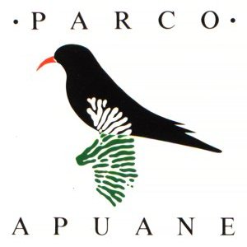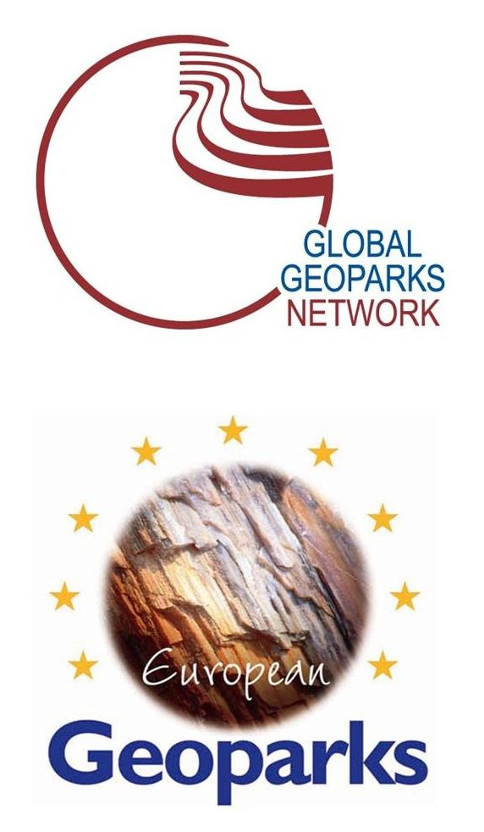

6th Workshop of Italian Geoparks

Enjoy the Geology! Enjology?
Geodiversity and typical food and wine

Parco Regionale delle Alpi Apuane – Apuan Alps Geopark
Castelnuovo of Garfagnana (Lucca)
3rd-6th June 2014

registration
(*)all fields marked with an asterisk are required
surname (*)
name (*)
organisation
address (*)
town (country) (*)
telephone (*)
mobile (*)
e-mail (*)
special requirements
please indicate who we should contact in case of emergency | name
please indicate who we should contact in case of emergency | surname
please indicate who we should contact in case of emergency | relationship to you
please indicate who we should contact in case of emergency | telephone
how many days do you plan to attend this…(*) | date |  |  |  | check
how many days do you plan to attend this…(*) | workshop | tuesday 3rd june |  |  | ◻ yes ◻ no
how many days do you plan to attend this…(*) | workshop | wednesday 4th june |  |  | ◻ yes ◻ no
how many days do you plan to attend this…(*) | workshop | thursday 5th june |  |  | ◻ yes ◻ no
how many days do you plan to attend this…(*) | field trip | friday 6th june |  |  | ◻ yes ◻ no
hotel in order of preference  (from 1 to 3)(*) | Hotel La Lanterna
hotel in order of preference  (from 1 to 3)(*) | Hotel The Marquee
hotel in order of preference  (from 1 to 3)(*) | Hotel Ludovico Ariosto
hotel in order of preference  (from 1 to 3)(*) | Hotel Da Carlino
hotel in order of preference  (from 1 to 3)(*) | Locanda Aquila d’Oro
other possibilities | ◻ accommodation c/o
other possibilities | ◻ daily attendance without accommodation

hotel booking service: I.A.T. Garfagnana Centro Visite Parchi Alpi Apuane e Appennino Tosco Emiliano
telephone +39 0583 65169 – fax 0583 644242 – e mail: garfagnana@tin.it

Accommodation expenses must be paid directly by the participant

Registration fee (*)
category of participant |  | attendance | €
GGN-EGN Geopark representative  (two persons maximum) | ◻ yes | ◻ workshop | 0,00
GGN-EGN Geopark representative  (two persons maximum) | ◻ yes | ◻ field trip | 0,00
GGN-EGN Geopark-additional representative (in addition to the two persons of the previous category) | ◻ yes | ◻ workshop | 50,00
 | ◻ yes | ◻ field trip | 25,00
aspiring Italian Geopark representative  (one person maximum) | ◻ yes | ◻ workshop | 0,00
 | ◻ yes | ◻ field trip | 0,00
aspiring Italian Geopark additional representative (in addition to the one person of the previous category) | ◻ yes | ◻ workshop | 75,00
 | ◻ yes | ◻ field trip | 37,50
Ordine dei Geologi member | ◻ yes | ◻ workshop | 75,00
Ordine dei Geologi member | ◻ yes | ◻ field trip | 37,50
Fist (Federazione Italiana di Scienze della Terra) member | ◻ yes | ◻ workshop | 75,00
Fist (Federazione Italiana di Scienze della Terra) member | ◻ yes | ◻ field trip | 37,50
Sigea (Società Italiana di Geologia Ambientale) member | ◻ yes | ◻ workshop | 75,00
Sigea (Società Italiana di Geologia Ambientale) member | ◻ yes | ◻ field trip | 37,50
Associazione Italiana di Geologia e Turismo (G&T) member | ◻ yes | ◻ workshop | 75,00
Associazione Italiana di Geologia e Turismo (G&T) member | ◻ yes | ◻ field trip | 37,50
other | ◻ yes | ◻ workshop | 100,00
other | ◻ yes | ◻ field trip | 50,00
Total €

Information about the trip
ARRIVAL |  |  | DEPARTURE
date (*) |  |  | date (*)
transport (*) | airplane | ◻ | transport (*) | airplane | ◻
transport (*) | train | ◻ | transport (*) | train | ◻
transport (*) | bus | ◻ | transport (*) | bus | ◻
transport (*) | car | ◻ | transport (*) | car | ◻
arrival at (*)  (specify airport, train station or bus station) |  |  | departure from (*)  (specify airport, train station or bus station)
arrival time (*) |  |  | departure time (*)
details about the trip |  |  | details about the trip

any requests and / or additional information

notes

- deadline for registration: 30th April 2014 – send registration to the email address: info@apuanegeopark.it

- registration fee at the workshop includes: lunch, dinner, internal transfers, museum tickets, theatre performance on 4th and 5th June 2014.

- registration fee at the field trip includes: lunch, internal transfer, Corchia system ticket on 6th June 2014.

